**Operating System Mini-project:**

**Topic: Client-Server File Transfer Protocol.**

**Team Members Name,Roll no and Work done:**

**Aditya Krishnan :115A1060:** Project help plus worked in documentation.

**Mohit Parulekar :115A1074:** Documentation work.

**Sidharth Chandran:115A1079:** Implemented the code and execution work.

LINUX BASED CLIENT SERVER APPLICATION

Background:

1. **DEFINITION:**

A client-server network is designed for end-users, called clients, to access resources such as files, songs, video collections, or some other service from a central computer called a server. A server's sole purpose is to do what its name implies - serve its clients.Its a centralised network.

2. **NEED:**

1)Peer to peer networks resulted into loss of data if a single machine fails

2)a control system to monitor which machine will send data and which order

3)Flexibility (connections on demand)

3. **ADVANTAGES:**

**Distribution**: Distribution is automatic, because new copies of the pages (the components of our application) are downloaded to the client machine whenever the local client cache says they need updating. No more walking round the building installing software, or expecting your Web site visitors to download and install it themselves.

**Flexibility**: The automatic distribution and installation means that applications can be updated much more easily. This is a huge benefit if the environment requires quick turn around on changes to the specifications or just bug fixes. Even 'Interface du jour' could be implemented, where different interfaces and content are deployed daily—of great interest to marketing departments when selling products.

**Central** **Control**: With the deployment of PC’s and local installations, the system administrators lost control, and help desk costs for maintaining non-standard desktops increased.

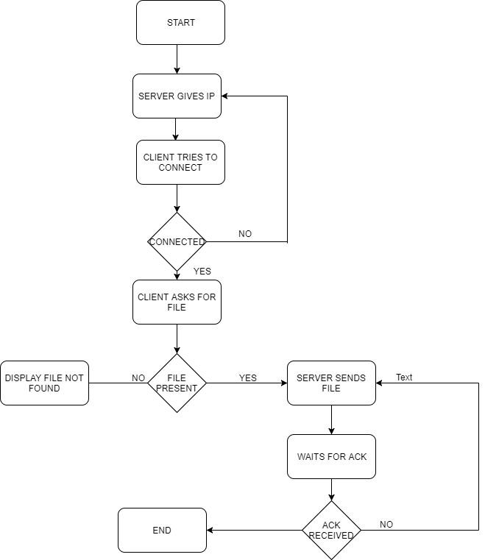

**METHODOLOGY**:

IN this documentation we intend to implement a client server architecture based file transfer program has been implemented in c program ,after executing client and serve scripts and when the server is ready to handle request from a client the client can request for a file to the server.

The server responses by sending to the client

The client can then be seen having that file. This presents a very fast to send and receive files

**IMPLEMENTATION:**

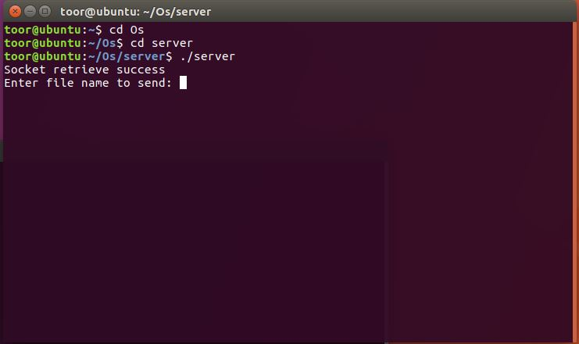

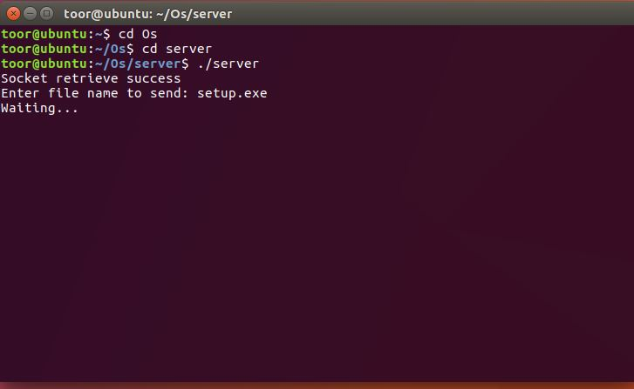

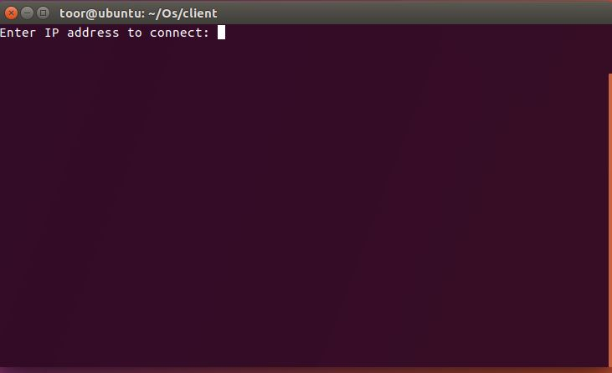

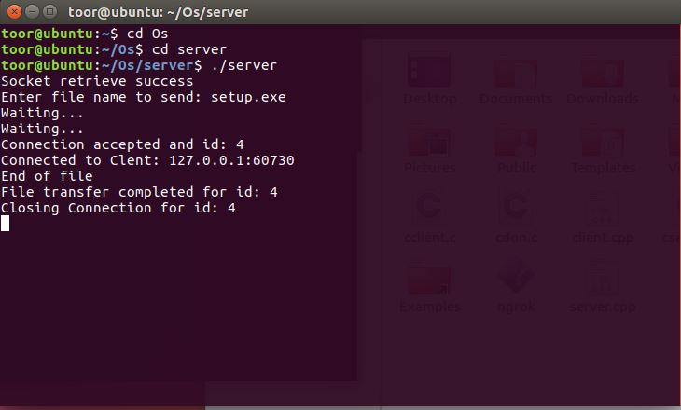

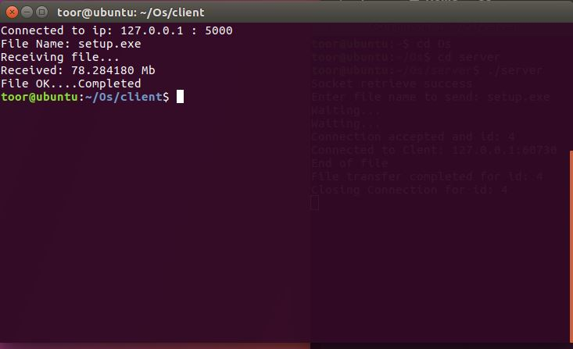

**CONCLUSION**:

Client server based file transfer application using linux is executed successfully.